
YJK Technologies

HCM -Pay Roll

Preface – Payroll Module
Welcome to the YJK HR User’s Guide – Payroll Module, release 1.0.
This guide provides all the information required to set up and use the Payroll module in YJK HR to meet your organization’s salary processing and employee compensation needs. It explains how to efficiently manage payroll activities and related employee self-service functions.
This guide includes detailed information about the following:
- Overview of Payroll and its key features
- How to use Payroll functionalities
- Payslip Master and Salary Processing
- Loan Management (Loan Type, Requests, Approvals, Payments, and Repayment Schedule)
- Payroll Reports and Tracking
This preface explains how this Payroll user guide is organized and introduces additional information that will help you understand and use the Payroll module effectively.

About this User’s Guide payroll Module

The YJK HR Payroll User’s Guide consists of the following chapters:

- Chapter 1 provides an overview of the Payroll system and its key features.
It explains how payroll processing works and includes important information about data security, user access control, and recommendations for payroll data backup and protection.

- Chapter 2 explains how to access the Payroll module, including login and logout procedures, and how users can manage their credentials such as changing passwords.

- Chapter 3 describes the Payslip Master, where salary structures are defined.
It explains how to configure earnings, deductions, and other salary components.

- Chapter 4 explains the Salary Process, including how to generate payroll, calculate salaries, and produce employee payslips.

- Chapter 5 covers the Loan Management module, including Loan Types, Loan Requests, and Loan Approvals.
It explains how employees can apply for loans and how administrators can review and approve them.

- Chapter 6 explains Loan Payment and Repayment Schedule, including loan disbursement, EMI calculation, and tracking repayment details.

- Chapter 7 provides information about Loan Status History and Payroll Reports, helping users track loan progress and analyze payroll data effectively.

Thank You

C H A P T E R

Introduction
The YJK HR Payroll module is designed to meet all essential payroll and compensation needs of small and medium enterprises. This powerful solution enables organizations to efficiently manage employee salary processing, payslips, and loan-related activities in a simple and structured manner.
The Payroll module provides a user-friendly, cost-effective, and automated system that helps organizations move away from traditional payroll methods. It ensures smooth handling of employee salary data, deductions, loan repayments, and financial records with accuracy and efficiency.
Managing payroll can be complex due to administrative responsibilities, compliance requirements, and detailed calculations. The YJK HR Payroll module simplifies this process by offering accurate and timely payroll processing with minimal effort.
With features like:
- Automated salary calculation
- Payslip generation
- Loan management and tracking
- Secure and reliable data handling
the system helps reduce manual work, minimize errors, and save valuable time and resources.
Overall, the Payroll module ensures a streamlined, transparent, and efficient payroll process, allowing organizations to focus more on their core business activities.

C H A P T E R

Pay Roll

About Payroll
Payroll is the process of managing and paying employee salaries within an organization. It includes calculating employee earnings, applying deductions, and ensuring timely salary disbursement.
The YJK HR Payroll module helps automate and simplify payroll activities, reducing manual effort and errors. It ensures accurate salary processing based on predefined salary structures and company policies.
The Payroll system typically includes:
- Salary Calculation – Based on employee pay structure, attendance, and allowances
- Deductions Management – Includes taxes, PF, ESI, loans, and other deductions
- Payslip Generation – Provides detailed salary breakdown for employees
- Loan Management – Handles loan requests, approvals, payments, and repayments
- Compliance Handling – Ensures payroll follows company and legal requirements
By using the Payroll module, organizations can achieve:
- Faster and error-free salary processing
- Improved transparency for employees
- Better record management and reporting
- Reduced administrative workload

Payroll Screen – Key Fields
The Payroll screen includes the following important fields used for salary processing:
- Salary – Total earnings of the employee for the selected period
- Eligibility Days – Number of payable days based on attendance
- Bonus – Additional earnings such as incentives or festival bonus
- PF Contribution – Provident Fund deduction (employee + employer share)
- Professional Tax – State-level tax deducted from salary
- TDS (Tax Deducted at Source) – Income tax deducted as per applicable rules

Conclusion
Overall, Payroll plays a crucial role in maintaining employee satisfaction and ensuring smooth financial operations within an organization. The inclusion of these payroll fields ensures accurate calculation, transparency, and compliance in salary processing.

Salary Eligibility Days
✧ Clicking on the First tab (Salary Eligibility Days), it navigates the user to the Salary Eligibility Days screen.
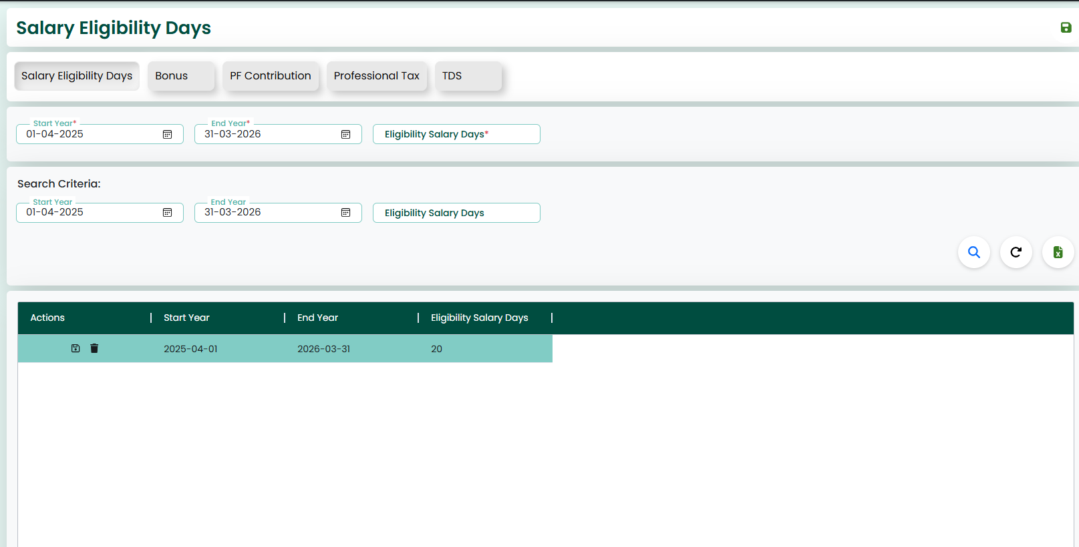
✧ The image shown above illustrates the Salary Eligibility Days screen.
✧ Each of the Payroll screens includes input fields such as Start Year, End Year, and Eligibility Salary Days. These fields are used to define and save salary eligibility details for a specific period.
Action Button
✧ This screen also features ‘Save’ and ‘Reload’ buttons located at the top-right corner.
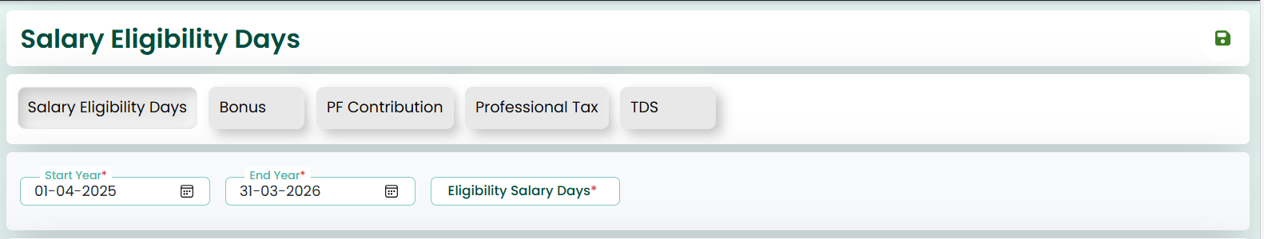
✧ On this screen, the user must enter the required details such as Start Year, End Year, and Eligibility Salary Days. After entering the data, by clicking the ‘Save’ button, the data will be saved successfully.
Search Criteria
✧ The Search Criteria section allows the user to search for existing records. The user can enter or select the required fields and use the search option to view saved data.
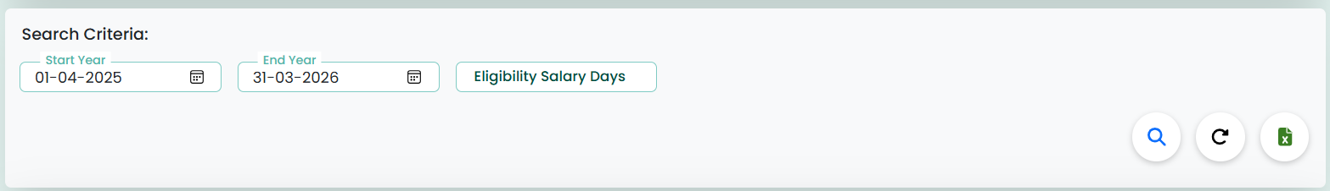
✧ Clicking on the Search icon will display the saved data for this screen. The user can view the records in the grid below.
Action Button
✧ If the user wants to update or delete the data, Edit and Delete options are available in the Actions column. These allow the user to modify or delete the data as needed.
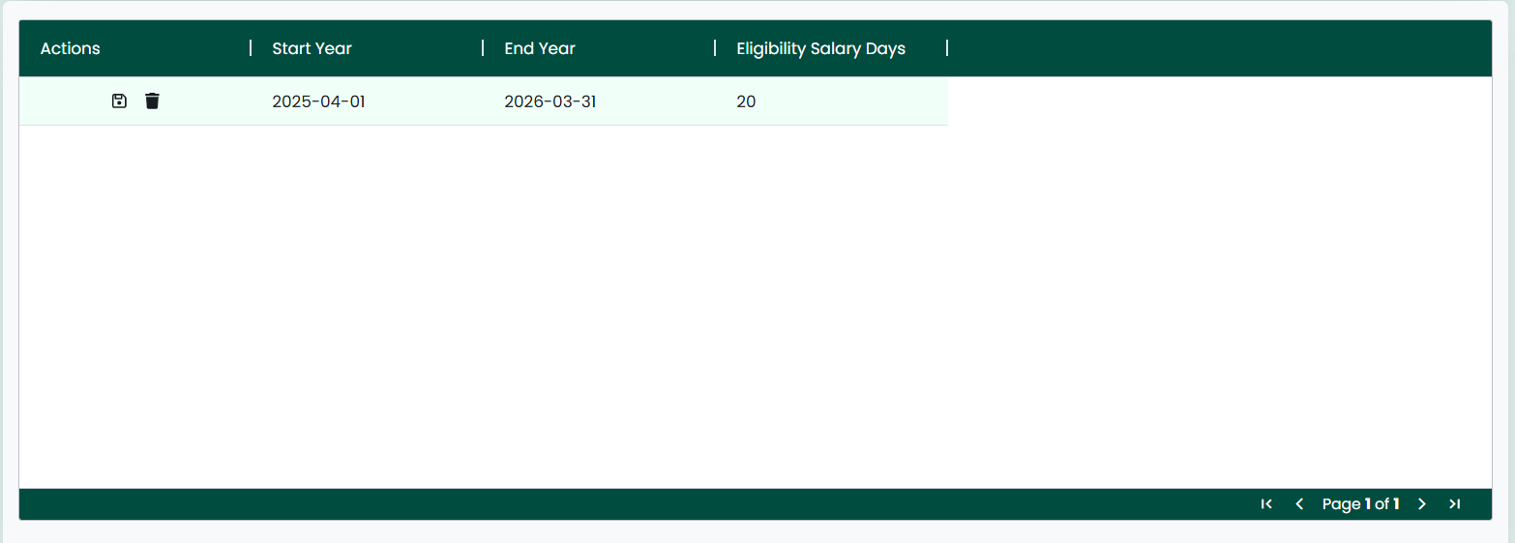
✧ Once the data is fetched, if the user wants to update it, they can modify the fields and save the changes.
✧ If the user wants to delete the record, they can click the delete option to remove the data.
Action Button
✧ The Reload button can be used to refresh the page, clearing all fields and resetting the screen to its initial state.
✧ The Export option (Excel icon) is available to download the displayed data for reporting purposes.

Bonus
✧ Clicking on the Bonus tab, it navigates the user to the Bonus screen.
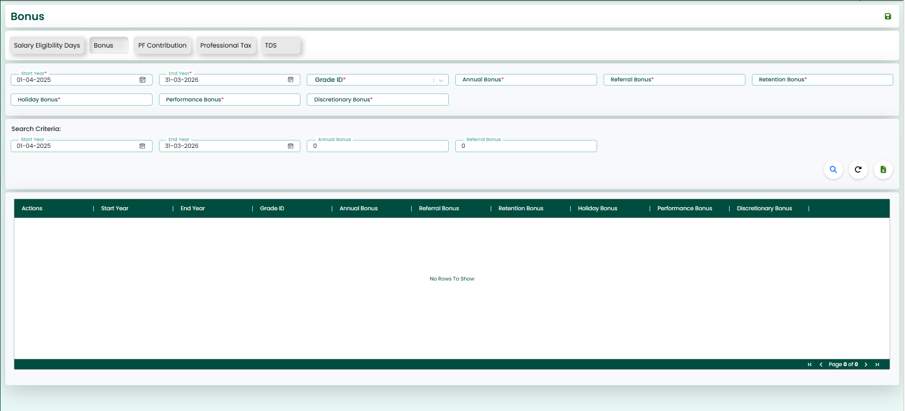
✧ The image shown above illustrates the Bonus screen.
✧ Each of the Payroll screens includes input fields such as Start Year, End Year, Grade ID, and various Bonus components. These fields are used to define bonus details for employees based on year and grade.
✧ This screen also features ‘Save’ and ‘Reload’ buttons located at the top-right corner.
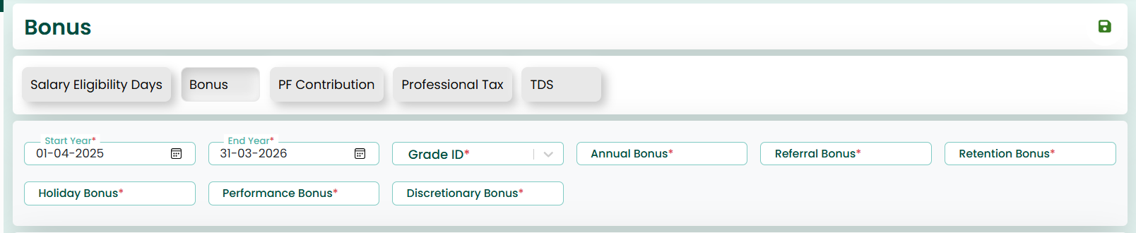
✧ On this screen, the user must enter the required details such as:
- Start Year
- End Year
- Grade ID
- Annual Bonus
- Referral Bonus
- Retention Bonus
- Holiday Bonus
- Performance Bonus
- Discretionary Bonus
After entering the data, by clicking the ‘Save’ button, the data will be saved successfully.
✧ The Search Criteria section allows the user to search for existing records. The user can enter or select fields such as:
- Start Year
- End Year
- Annual Bonus
- Referral Bonus
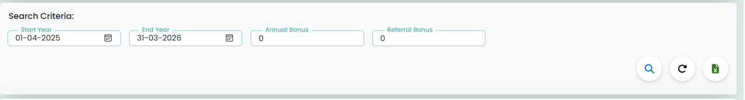
✧ Clicking on the Search button/icon will display the saved data for this screen. The user can view the records in the grid below.
✧ The user can select the required record and perform necessary actions.
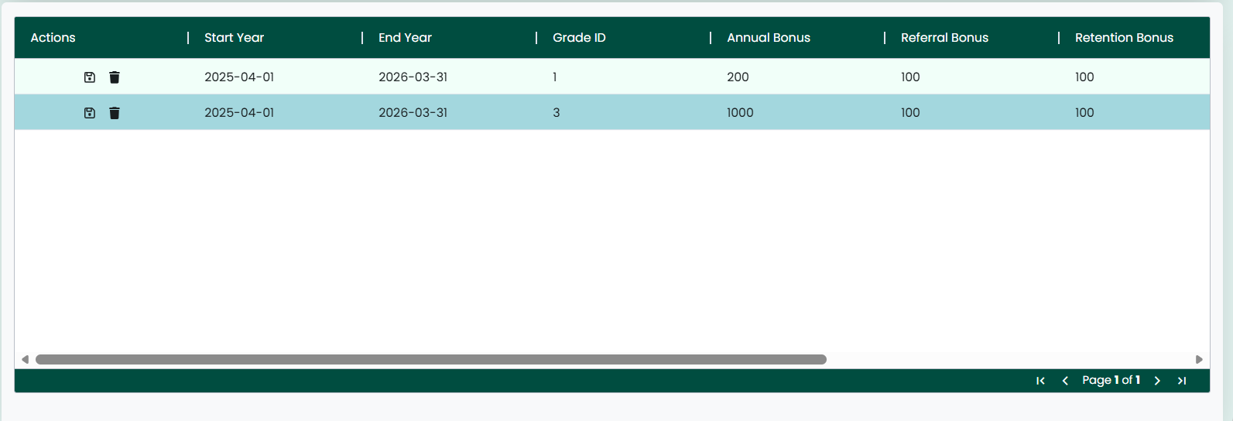
✧ If the user wants to update or delete the data, Edit and Delete options are available in the Actions column. These allow the user to modify or delete the data as needed.
✧ Once the data is fetched, if the user wants to update it, they can modify the fields and save the changes.
✧ If the user wants to delete the record, they can click the delete option to remove the data.
✧ The Reload button can be used to refresh the page, clearing all fields and resetting the screen to its initial state.
✧ The Excel option is available to download the displayed data for reporting purposes.
PF Contribution
✧ Clicking on the PF Contribution tab, it navigates the user to the PF Contribution screen.
✧ The image shown above illustrates the PF Contribution screen.
✧ Each of the Payroll screens includes input fields such as Start Year, End Year, Company Contribution, and Employee PF. These fields are used to define provident fund contribution details for a specific period.
✧ This screen also features ‘Save’ and ‘Reload’ buttons located at the top-right corner.
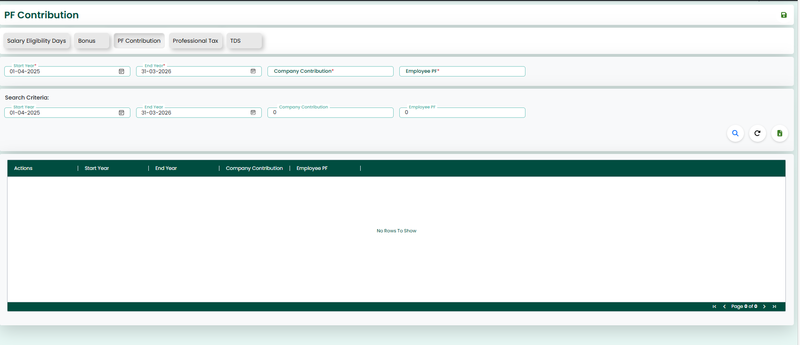
✧ On this screen, the user must enter the required details such as:
- Start Year
- End Year
- Company Contribution
- Employee PF
After entering the data, by clicking the ‘Save’ button, the data will be saved successfully.
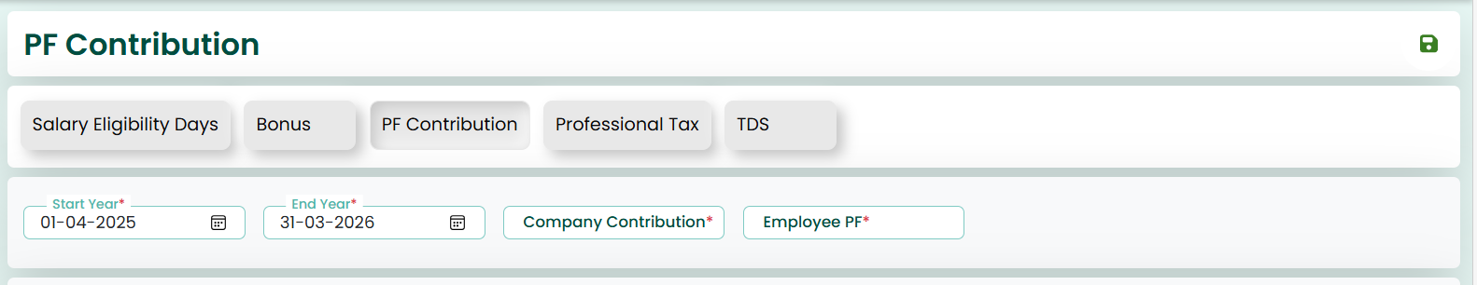
✧ The Search Criteria section allows the user to search for existing records. The user can enter or select fields such as:
- Start Year
- End Year
- Company Contribution
- Employee PF
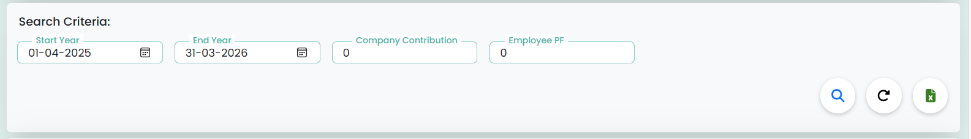
✧ Clicking on the Search button/icon will display the saved data for this screen. The user can view the records in the grid below.
✧ The user can select the required record and perform necessary actions.
✧ If the user wants to update or delete the data, Edit and Delete options are available in the Actions column. These allow the user to modify or delete the data as needed.
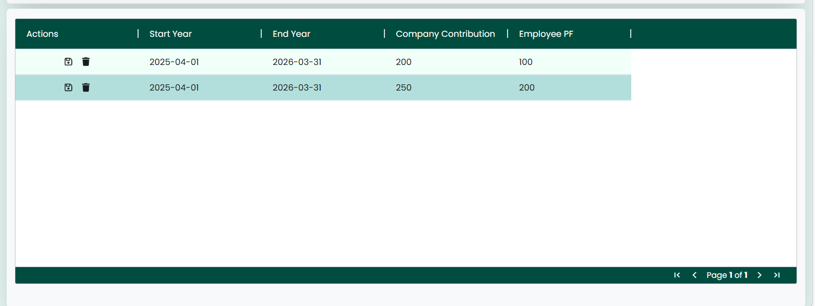
✧ Once the data is fetched, if the user wants to update it, they can modify the fields and save the changes.
✧ If the user wants to delete the record, they can click the delete option to remove the data.
✧ The Reload button can be used to refresh the page, clearing all fields and resetting the screen to its initial state.

Professional Tax
✧ Clicking on the Professional Tax tab, it navigates the user to the Professional Tax screen.
✧ The image shown above illustrates the Professional Tax screen.
✧ Each of the Payroll screens includes input fields such as Start Year, End Year, Employee Salary From, Employee Salary To, and Taxable Amount. These fields are used to define professional tax slabs based on employee salary range.
✧ This screen also features ‘Save’ and ‘Reload’ buttons located at the top-right corner.
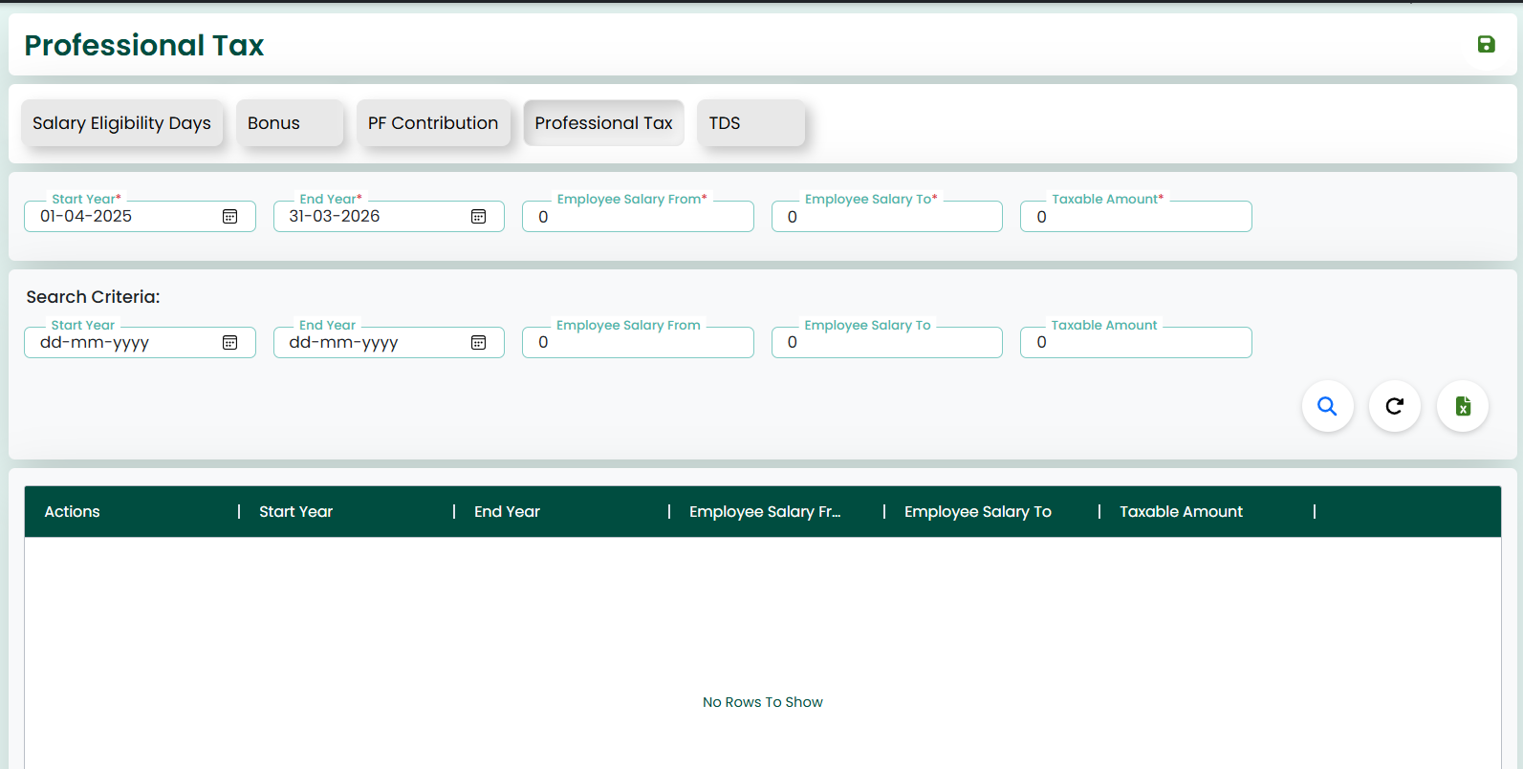
✧ On this screen, the user must enter the required details such as:
- Start Year
- End Year
- Employee Salary From
- Employee Salary To
- Taxable Amount
After entering the data, by clicking the ‘Save’ button, the data will be saved successfully.
✧ The Search Criteria section allows the user to search for existing records. The user can enter or select fields such as:
- Start Year
- End Year
- Employee Salary From
- Employee Salary To
- Taxable Amount
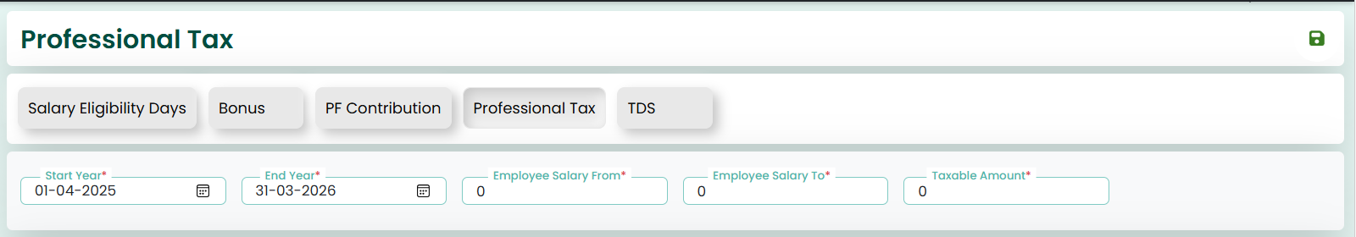
✧ Clicking on the Search button/icon will display the saved data for this screen. The user can view the records in the grid below.
✧ The user can select the required record and perform necessary actions.
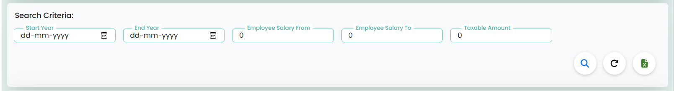
✧ If the user wants to update or delete the data, Edit and Delete options are available in the Actions column. These allow the user to modify or delete the data as needed.
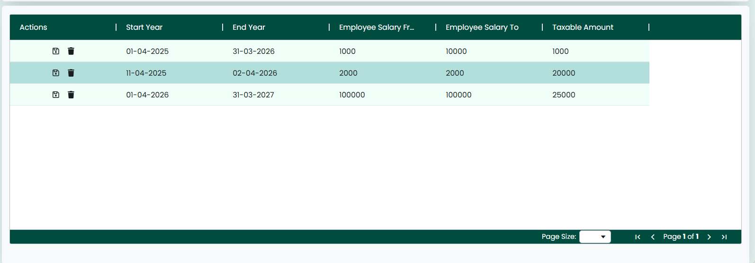
✧ Once the data is fetched, if the user wants to update it, they can modify the fields and save the changes.
✧ If the user wants to delete the record, they can click the delete option to remove the data.
✧ The Reload button can be used to refresh the page, clearing all fields and resetting the screen to its initial state.
✧ The Excel option is available to download the displayed data for reporting purposes.

TDS (Tax Deducted at Source)
✧ Clicking on the TDS tab, it navigates the user to the TDS screen.
✧ The image shown above illustrates the TDS screen.
✧ Each of the Payroll screens includes input fields such as Start Year, End Year, Employee Salary, and Taxable Amount. These fields are used to define tax deductions based on employee salary.
✧ This screen also features ‘Save’ and ‘Reload’ buttons located at the top-right corner.
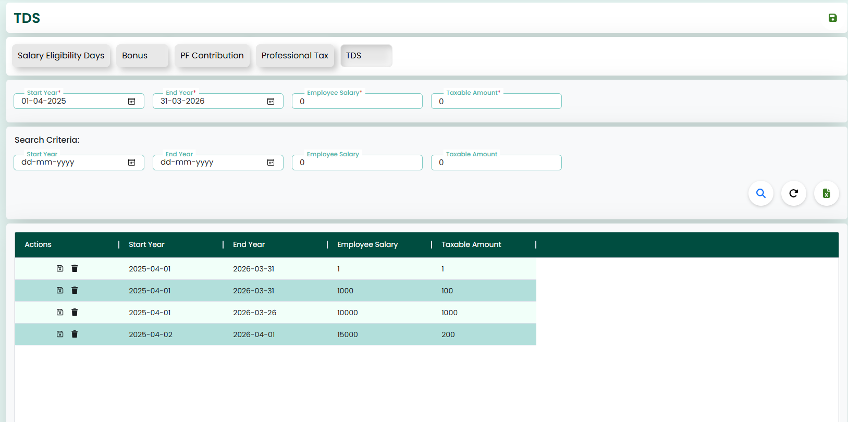
✧ On this screen, the user must enter the required details such as:
- Start Year
- End Year
- Employee Salary
- Taxable Amount
After entering the data, by clicking the ‘Save’ button, the data will be saved successfully.
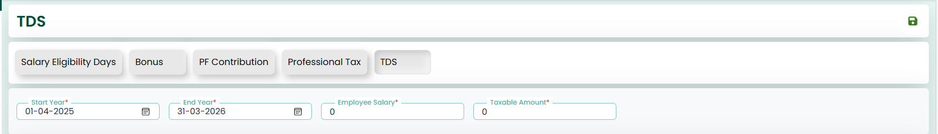
✧ The Search Criteria section allows the user to search for existing records. The user can enter or select fields such as:
- Start Year
- End Year
- Employee Salary
- Taxable Amount
✧ Clicking on the Search button/icon will display the saved data for this screen. The user can view the records in the grid below.
✧ The user can select the required record and perform necessary actions.
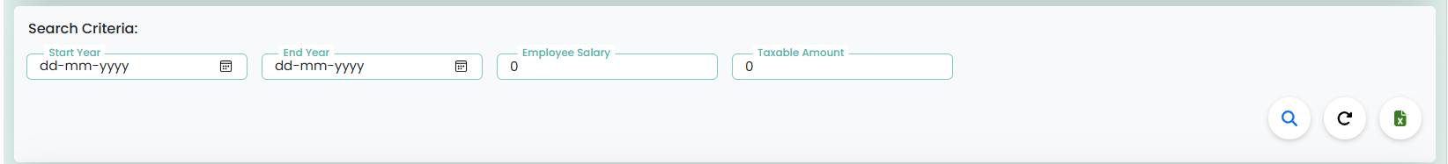
✧ If the user wants to update or delete the data, Edit and Delete options are available in the Actions column. These allow the user to modify or delete the data as needed.
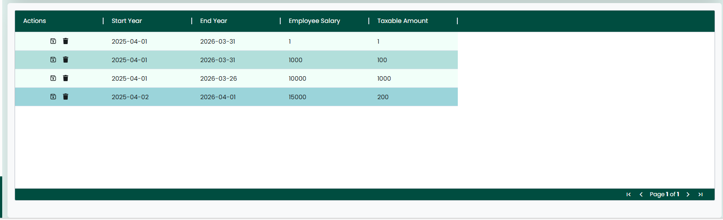
✧ Once the data is fetched, if the user wants to update it, they can modify the fields and save the changes.
✧ If the user wants to delete the record, they can click the delete option to remove the data.
✧ The Reload button can be used to refresh the page, clearing all fields and resetting the screen to its initial state.
✧ The Excel option is available to download the displayed data for reporting purposes.

C H A P T E R

Salary Process

Salary Process
✧ Clicking on the Salary Process tab navigates the user to the Salary Process screen.
✧ The screen is designed to manage and process employee salary details for a selected period.
✧ Each Payroll screen includes input fields such as Employee ID and Salary Month, which are used to process the salary for a specific employee and time period.
✧ This screen also features ‘Generate Pay Slip’ and ‘Reload’ buttons located at the top-right corner.
Data Entry Section
✧ On this screen, the user must enter the required details such as:
- Employee ID
- Salary Month
✧ After entering the data, clicking the ‘Generate Pay Slip’ button will process and save the salary details successfully.
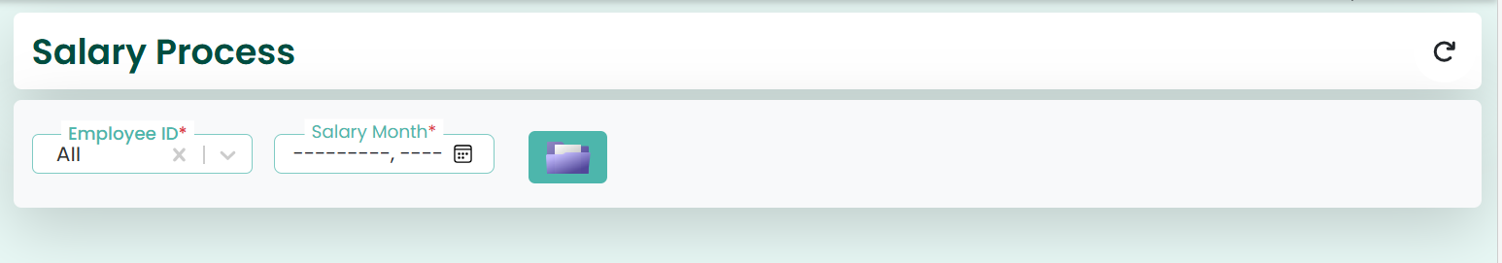

C H A P T E R

4 Loan Details

Loan Details (Add Loan Details)
✧ Clicking on the Loan Details tab navigates the user to the Loan Details screen.
✧ The image shown above illustrates the Loan Details screen.
✧ Each of the Payroll screens includes input fields such as Employee ID, Loan ID, Approved By, Loan Eligible Amount, Effective From Date, Effective End Date, How Many Months, and EMI Amount. These fields are used to manage and process employee loan information.
✧ This screen also features ‘Save’ and ‘Reload’ buttons located at the top-right corner.
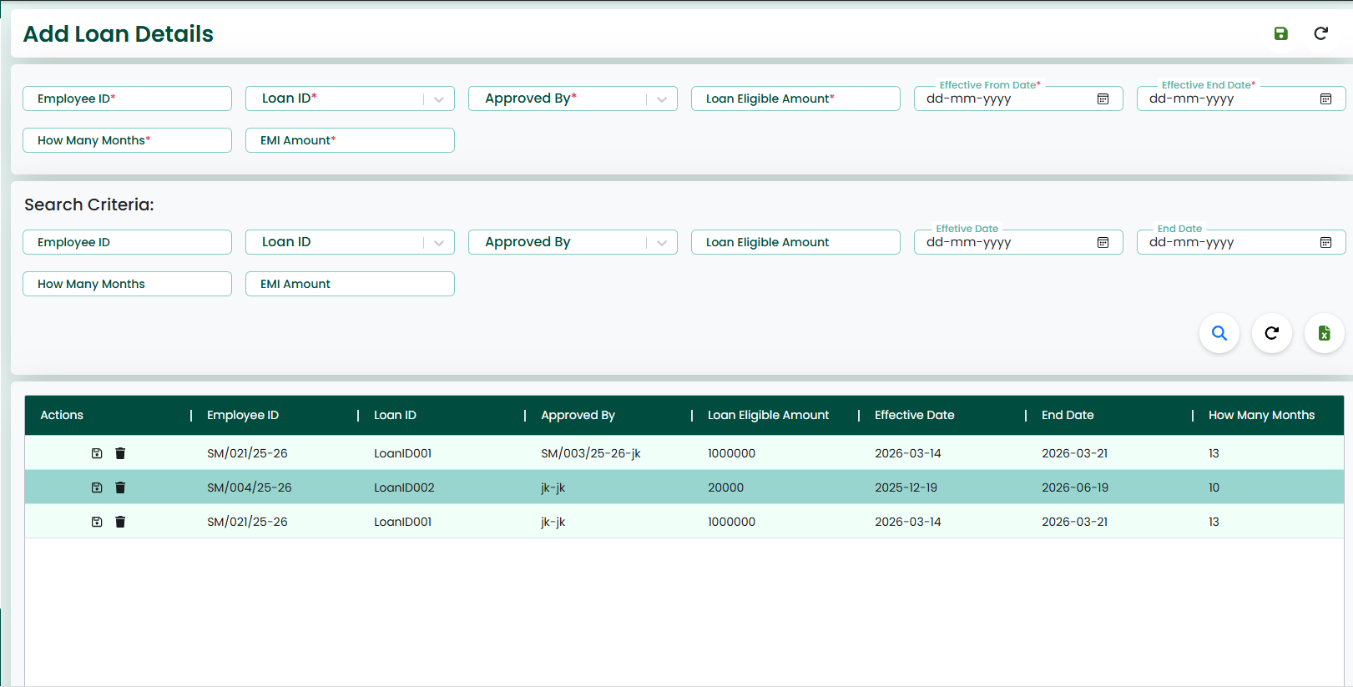
Data Entry Section
✧ On this screen, the user must enter the required details such as:
- Employee ID
- Loan ID
- Approved By
- Loan Eligible Amount
- Effective From Date
- Effective End Date
- How Many Months
- EMI Amount
✧ After entering the data, by clicking the ‘Save’ button, the loan details will be saved successfully.
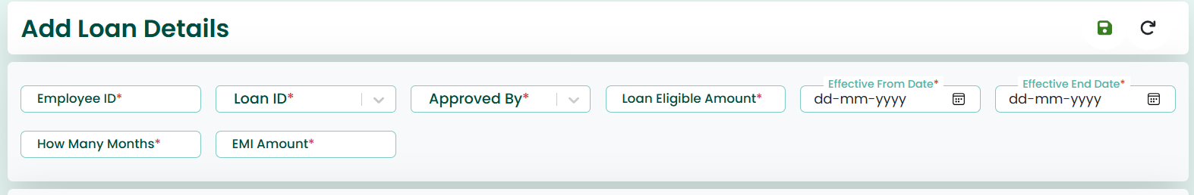
Search Criteria Section
✧ The Search Criteria section allows the user to search for existing loan records. The user can enter or select fields such as:
- Employee ID
- Loan ID
- Approved By
- Loan Eligible Amount
- Effective Date
- End Date
- How Many Months
- EMI Amount
✧ Clicking on the Search button/icon will display the saved data for this screen. The user can view the records in the grid below.
✧ The user can select the required record and perform necessary actions.
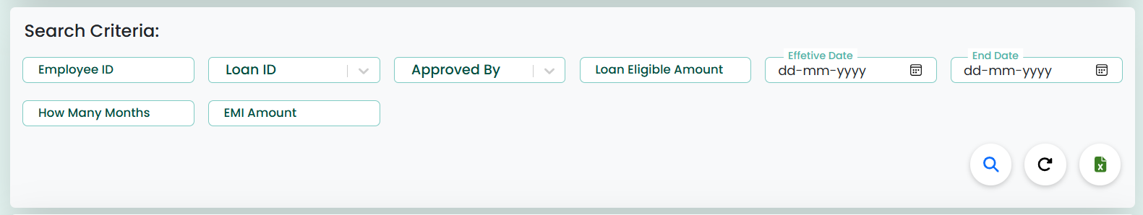
Actions (Edit/Delete)
✧ If the user wants to update or delete the data, Edit and Delete options are available in the Actions column. These allow the user to modify or delete the data as needed.
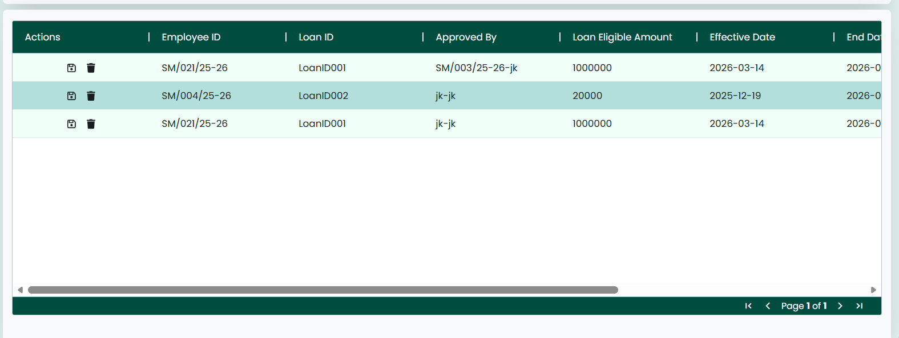
Update & Delete Functionality
✧ Once the data is fetched, if the user wants to update it, they can modify the fields and save the changes.
✧ If the user wants to delete the record, they can click the delete option to remove the data.
Action button
✧ The Reload button can be used to refresh the page, clearing all fields and resetting the screen to its initial state.
✧ The Excel option is available to download the displayed data for reporting purposes.

C H A P T E R

5 Loan Type
✧ Clicking on the Loan Type tab navigates the user to the Loan Type screen.
✧ The screen is used to define and manage different types of loans offered to employees.
✧ Each of the Payroll screens includes input fields such as Start Year, End Year, Loan Type ID, Loan Type Name, Maximum Amount, Maximum Repayment Months, Default Interest Rate, Description, and Status. These fields help in configuring loan policies.
✧ This screen also features ‘Save’ and ‘Reload’ buttons located at the top-right corner.
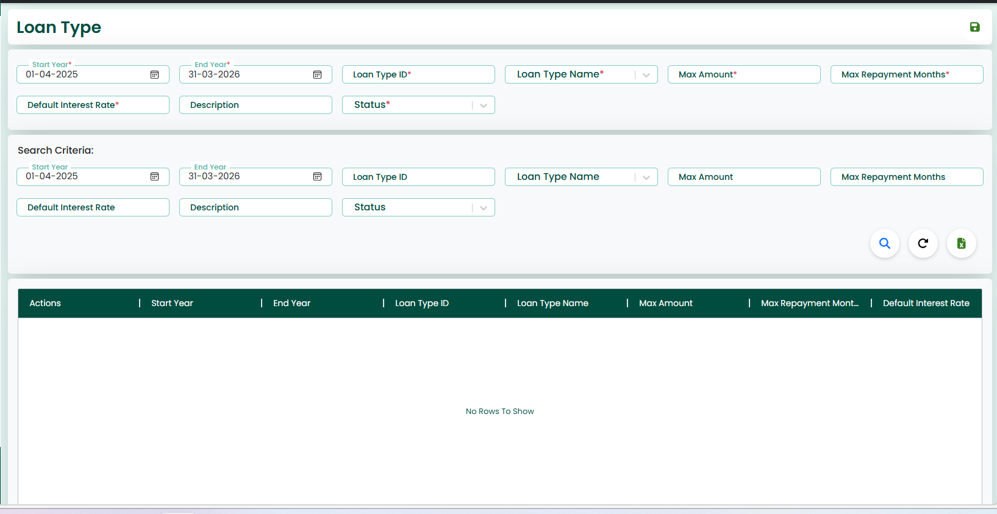
Data Entry Section
✧ On this screen, the user must enter the required details such as:
- Start Year
- End Year
- Loan Type ID
- Loan Type Name
- Max Amount
- Max Repayment Months
- Default Interest Rate
- Description
- Status
✧ After entering the data, by clicking the ‘Save’ button, the loan type details will be saved successfully.
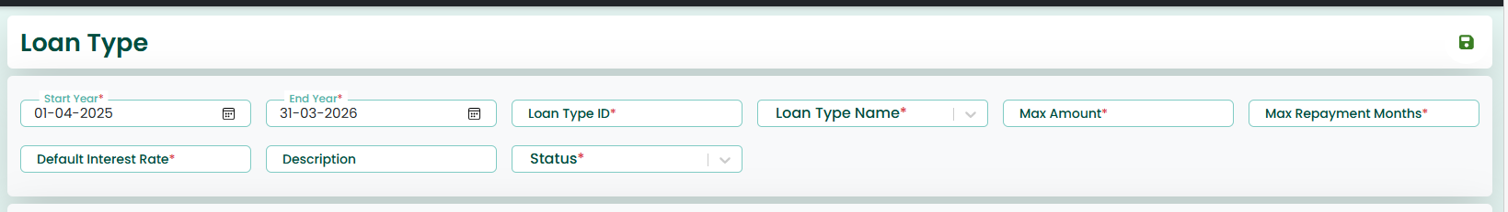
Search Criteria Section
✧ The Search Criteria section allows the user to search for existing loan type records. The user can enter or select fields such as:
- Start Year
- End Year
- Loan Type ID
- Loan Type Name
- Max Amount
- Max Repayment Months
- Default Interest Rate
- Description
- Status
✧ Clicking on the Search button/icon will display the saved data for this screen. The user can view the records in the grid below.
✧ The user can select the required record and perform necessary actions.
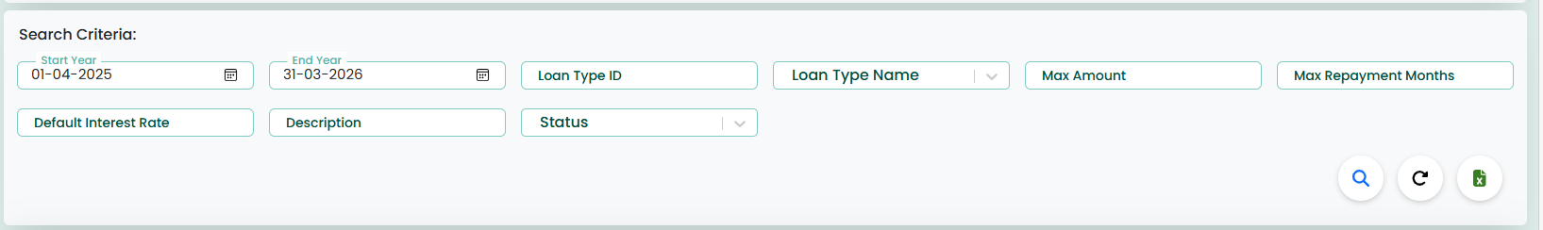
Actions (Edit/Delete)
✧ If the user wants to update or delete the data, Edit and Delete options are available in the Actions column. These allow the user to modify or delete the data as needed.

Update & Delete Functionality
✧ Once the data is fetched, if the user wants to update it, they can modify the fields and save the changes.
✧ If the user wants to delete the record, they can click the delete option to remove the data.
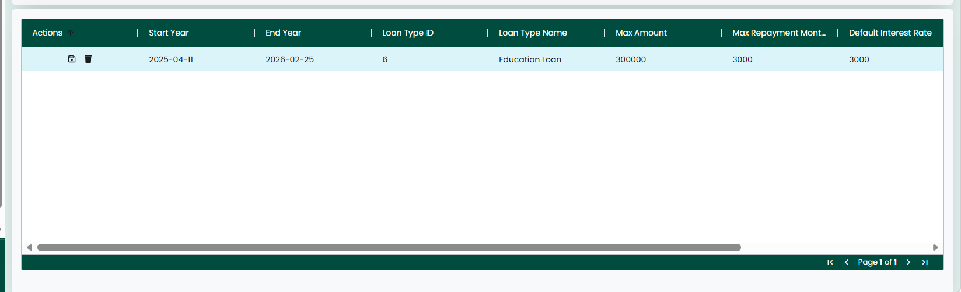
Additional Features
✧ The Reload button can be used to refresh the page, clearing all fields and resetting the screen to its initial state.
✧ The Excel option is available to download the displayed data for reporting purposes.

C H A P T E R

5 Loan Document
✧ Clicking on the Loan Documents tab navigates the user to the Loan Documents screen.
✧ The screen is used to upload, manage, and maintain documents related to employee loan requests.
✧ Each of the Payroll screens includes input fields such as Document ID, Loan Request ID, Document Type, File Path, Uploaded By, and Uploaded Date. These fields help in storing and tracking loan-related documents.
✧ This screen also features ‘Save’ and ‘Reload’ buttons located at the top-right corner.
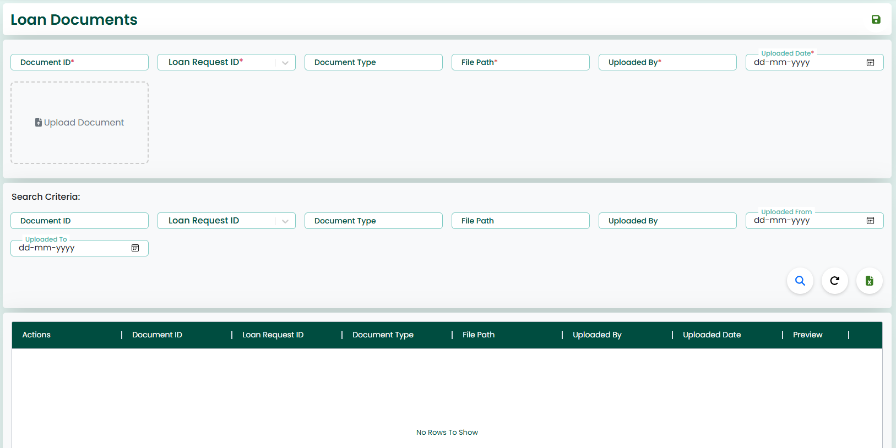
Data Entry Section
✧ On this screen, the user must enter the required details such as:
- Document ID
- Loan Request ID
- Document Type
- File Path
- Uploaded By
- Uploaded Date
✧ The Upload Document option allows the user to attach relevant files (such as proof documents, agreements, etc.).
✧ After entering the data and uploading the document, by clicking the ‘Save’ button, the details will be saved successfully.
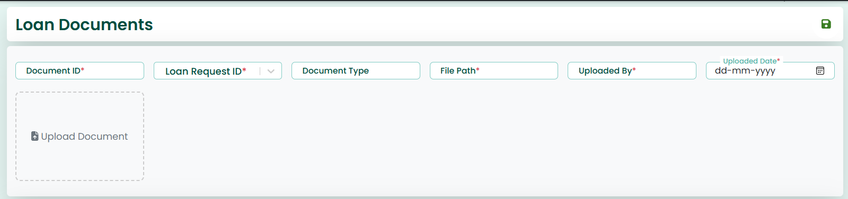
Search Criteria Section
✧ The Search Criteria section allows the user to search for existing document records. The user can enter or select fields such as:
- Document ID
- Loan Request ID
- Document Type
- File Path
- Uploaded By
- Uploaded From
- Uploaded To
✧ Clicking on the Search button/icon will display the saved data for this screen. The user can view the records in the grid below.
✧ The user can select the required record and perform necessary actions.
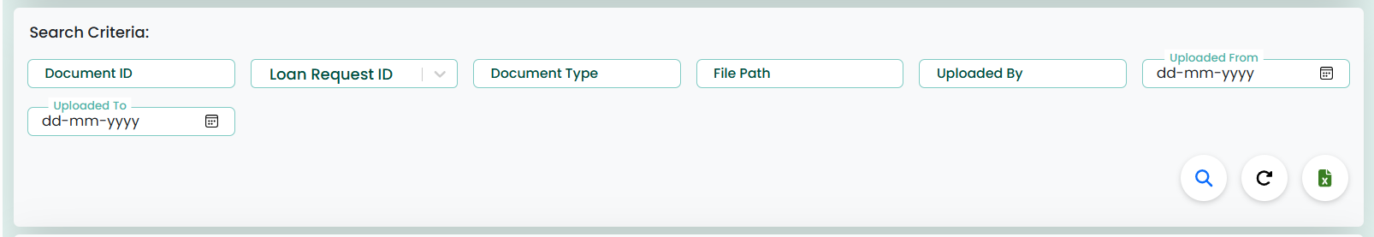
Actions (Edit/Delete)
✧ If the user wants to update or delete the data, Edit and Delete options are available in the Actions column. These allow the user to modify or delete the data as needed.

Update & Delete Functionality
✧ Once the data is fetched, if the user wants to update it, they can modify the fields and save the changes.
✧ If the user wants to delete the record, they can click the delete option to remove the data.
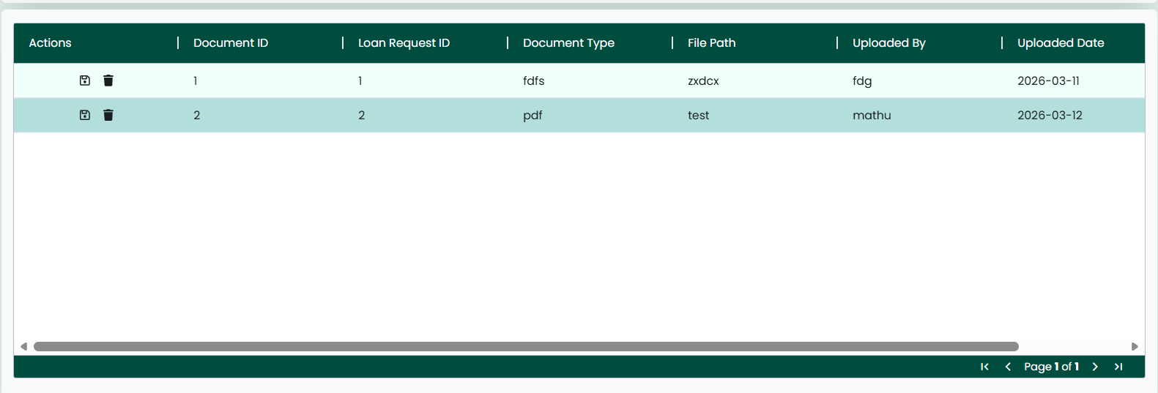
Additional Features
✧ The Reload button can be used to refresh the page, clearing all fields and resetting the screen to its initial state.
✧ The Excel option is available to download the displayed data for reporting purposes.

C H A P T E R

5 Loan Request
✧ Clicking on the Loan Request tab navigates the user to the Loan Request screen.
✧ The screen is used to create and manage employee loan requests.
✧ Each of the Payroll screens includes input fields such as Employee ID, Request Number, Loan Type ID, Loan Amount, Interest Rate, Repayment Months, Monthly Installment, Currency Code, Purpose, and Repayment Date. These fields help in capturing complete loan request details.
✧ This screen also features ‘Save’ and ‘Reload’ buttons located at the top-right corner.
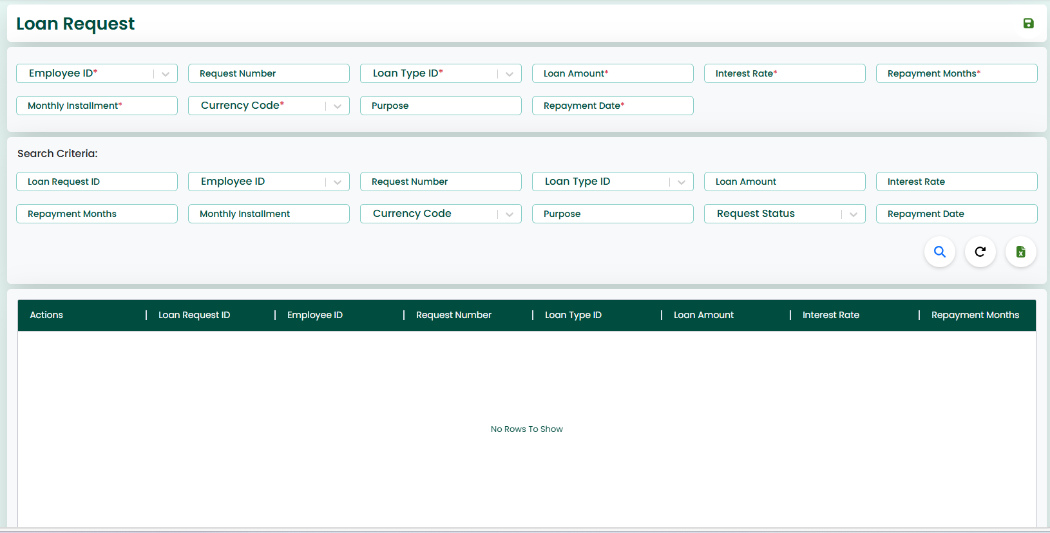
Data Entry Section
✧ On this screen, the user must enter the required details such as:
- Employee ID
- Request Number
- Loan Type ID
- Loan Amount
- Interest Rate
- Repayment Months
- Monthly Installment
- Currency Code
- Purpose
- Repayment Date
✧ After entering the data, by clicking the ‘Save’ button, the loan request details will be saved successfully.
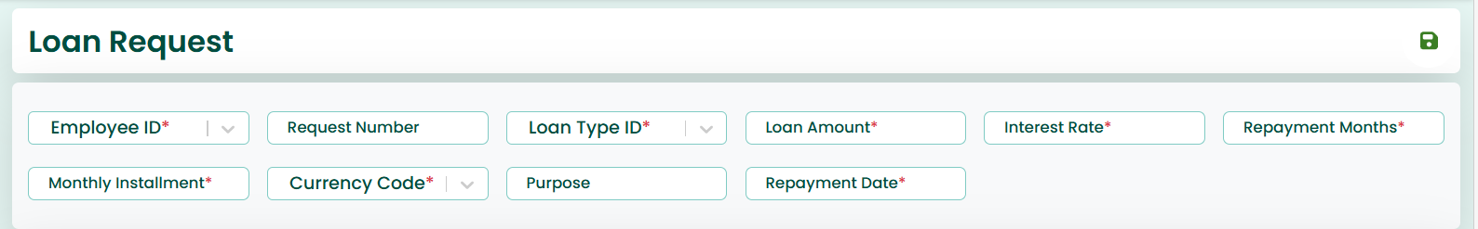
Search Criteria Section
✧ The Search Criteria section allows the user to search for existing loan request records. The user can enter or select fields such as:
- Loan Request ID
- Employee ID
- Request Number
- Loan Type ID
- Loan Amount
- Interest Rate
- Repayment Months
- Monthly Installment
- Currency Code
- Purpose
- Request Status
- Repayment Date
✧ Clicking on the Search button/icon will display the saved data for this screen. The user can view the records in the grid below.
✧ The user can select the required record and perform necessary actions.
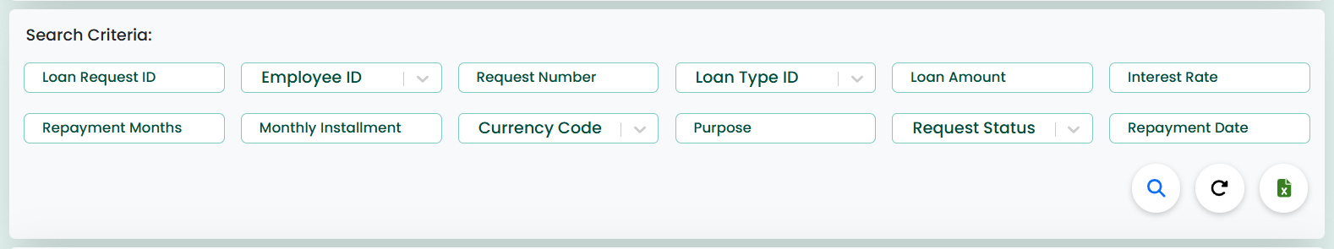
Actions (Edit/Delete)
✧ If the user wants to update or delete the data, Edit and Delete options are available in the Actions column. These allow the user to modify or delete the data as needed.

Update & Delete Functionality
✧ Once the data is fetched, if the user wants to update it, they can modify the fields and save the changes.
✧ If the user wants to delete the record, they can click the delete option to remove the data.
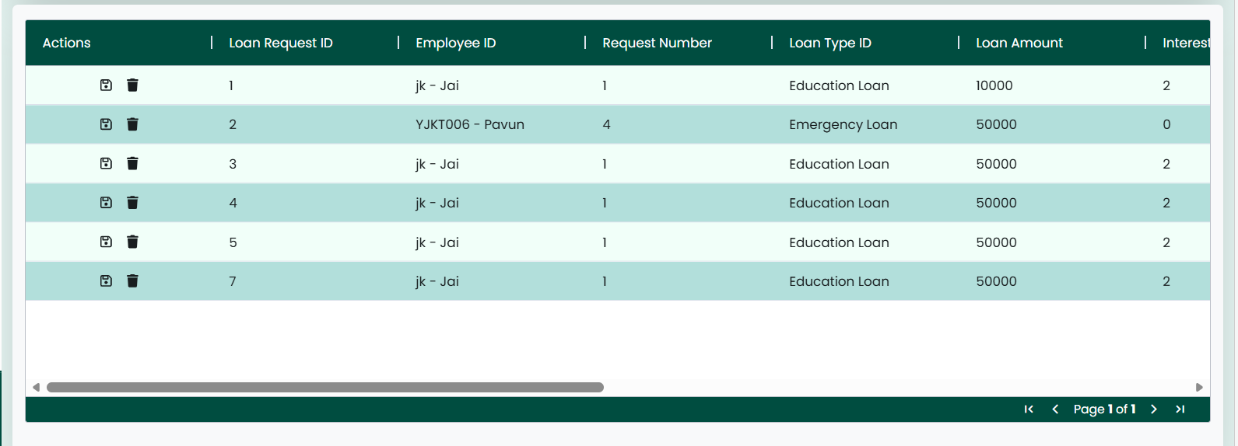
Additional Features
✧ The Reload button can be used to refresh the page, clearing all fields and resetting the screen to its initial state.
✧ The Excel option is available to download the displayed data for reporting purposes.

C H A P T E R

6 Loan Approval
✧ Clicking on the Loan Approval tab navigates the user to the Loan Approval screen.
✧ The screen is used to manage and track the approval process for employee loan requests.
✧ Each of the Payroll screens includes input fields such as Approval ID, Loan Request ID, Approver ID, Approval Level, Approval Status, Approval Date, and Remarks. These fields help in handling multi-level loan approvals.
✧ This screen also features ‘Save’ and ‘Reload’ buttons located at the top-right corner.
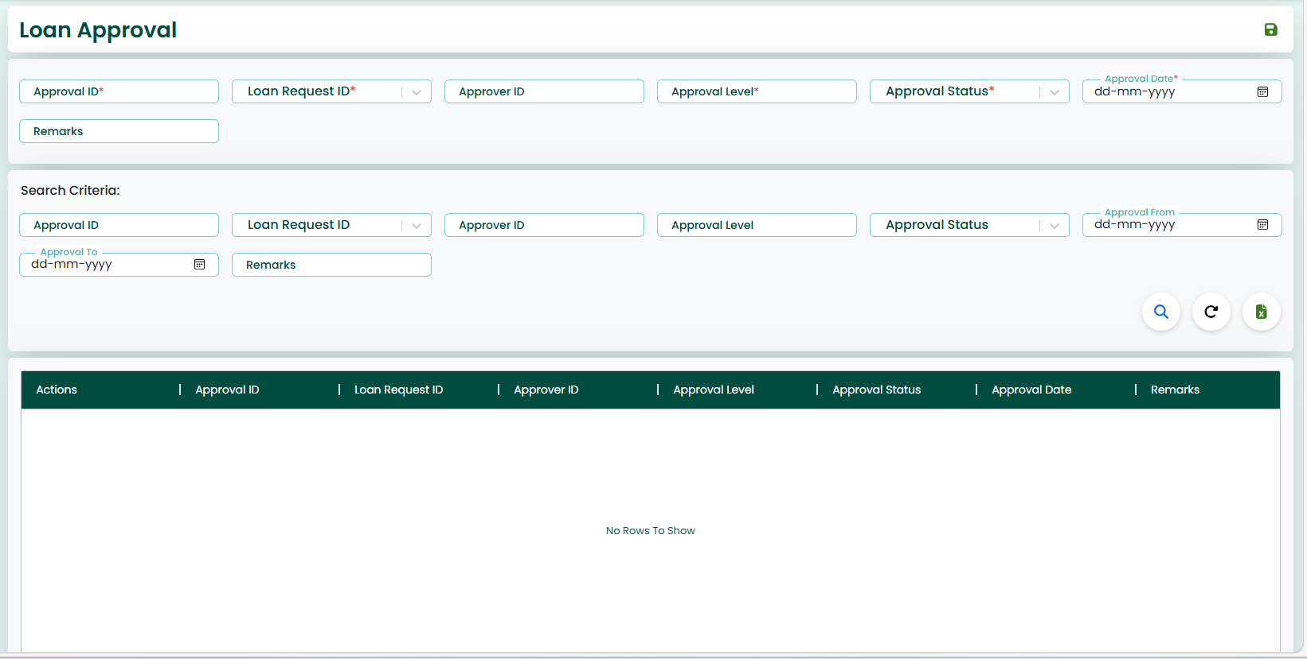
Data Entry Section
✧ On this screen, the user must enter the required details such as:
- Approval ID
- Loan Request ID
- Approver ID
- Approval Level
- Approval Status
- Approval Date
- Remarks
✧ After entering the data, by clicking the ‘Save’ button, the approval details will be saved successfully.
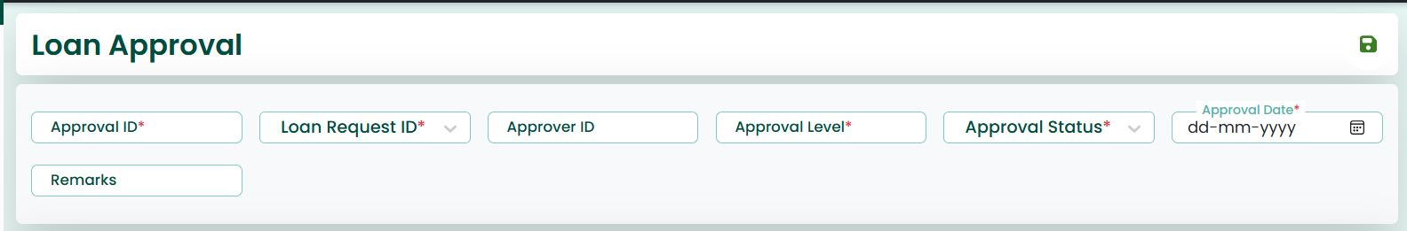
Search Criteria Section
✧ The Search Criteria section allows the user to search for existing loan approval records. The user can enter or select fields such as:
- Approval ID
- Loan Request ID
- Approver ID
- Approval Level
- Approval Status
- Approval From
- Approval To
- Remarks
✧ Clicking on the Search button/icon will display the saved data for this screen. The user can view the records in the grid below.
✧ The user can select the required record and perform necessary actions.
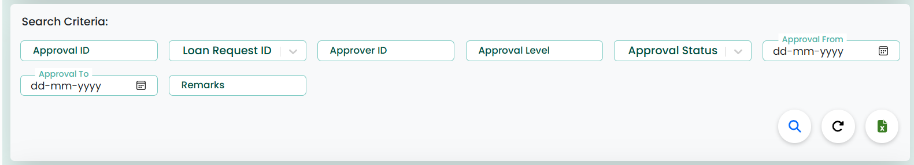
Actions (Edit/Delete)
✧ If the user wants to update or delete the data, Edit and Delete options are available in the Actions column. These allow the user to modify or delete the data as needed.
Update & Delete Functionality
✧ Once the data is fetched, if the user wants to update it, they can modify the fields and save the changes.
✧ If the user wants to delete the record, they can click the delete option to remove the data.
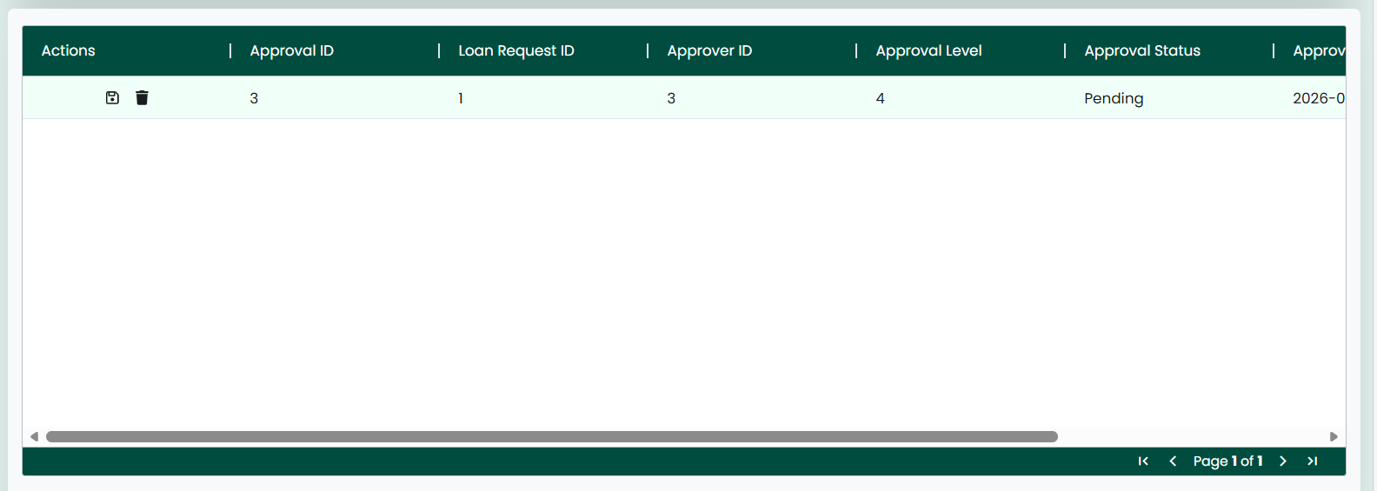
Additional Features
✧ The Reload button can be used to refresh the page, clearing all fields and resetting the screen to its initial state.
✧ The Excel option is available to download the displayed data for reporting purposes.

C H A P T E R

6 Loan Payment
✧ Clicking on the Loan Payment tab navigates the user to the Loan Payment screen.
✧ The screen is used to record and manage payments made towards employee loans.
✧ Each of the Payroll screens includes input fields such as Payment ID, Loan Request ID, Payment Date, Paid Amount, and Payment Method. These fields help in tracking loan repayment transactions.
✧ This screen also features ‘Save’ and ‘Reload’ buttons located at the top-right corner.
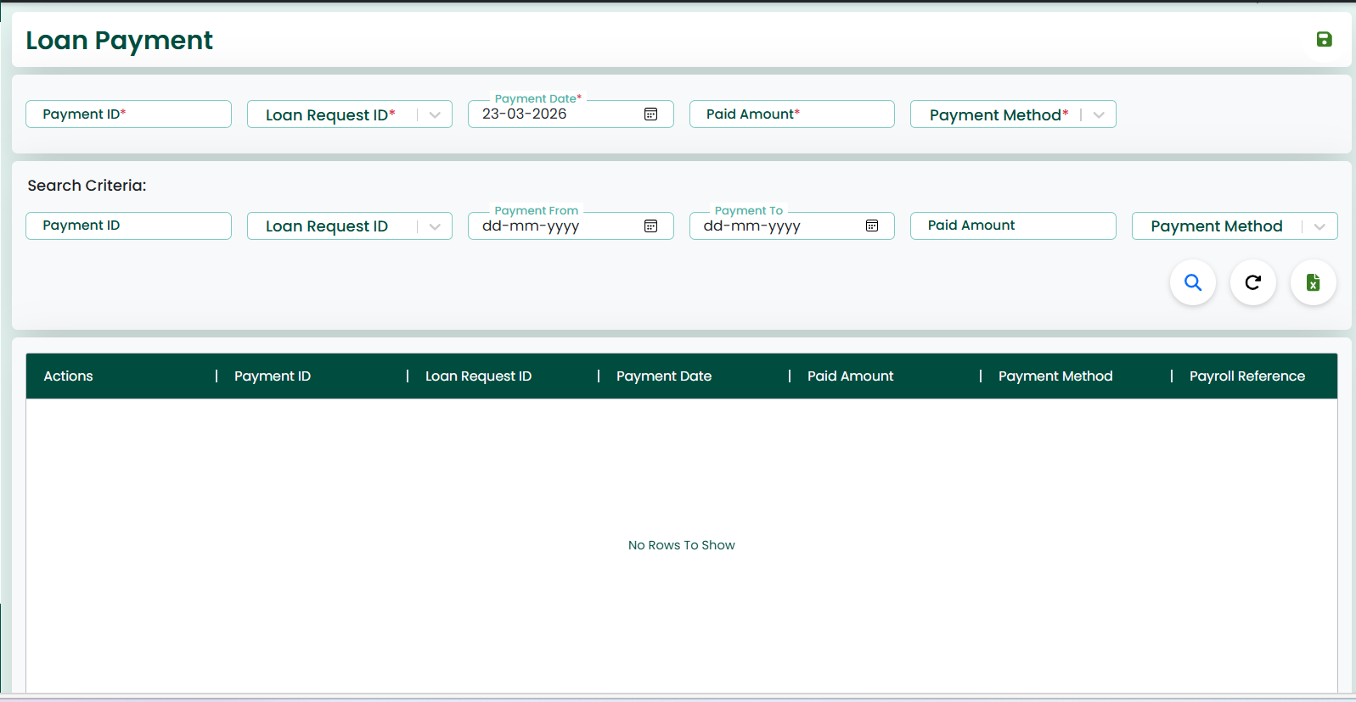
Data Entry Section
✧ On this screen, the user must enter the required details such as:
- Payment ID
- Loan Request ID
- Payment Date
- Paid Amount
- Payment Method
✧ After entering the data, by clicking the ‘Save’ button, the payment details will be saved successfully.
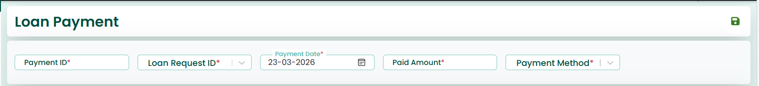
Search Criteria Section
✧ The Search Criteria section allows the user to search for existing loan payment records. The user can enter or select fields such as:
- Payment ID
- Loan Request ID
- Payment From
- Payment To
- Paid Amount
- Payment Method
✧ Clicking on the Search button/icon will display the saved data for this screen. The user can view the records in the grid below.
✧ The user can select the required record and perform necessary actions.
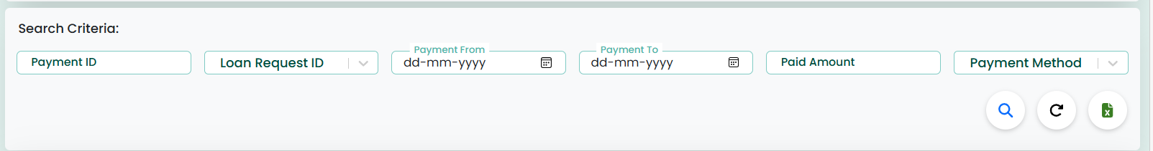
Actions (Edit/Delete)
✧ If the user wants to update or delete the data, Edit and Delete options are available in the Actions column. These allow the user to modify or delete the data as needed.
Update & Delete Functionality
✧ Once the data is fetched, if the user wants to update it, they can modify the fields and save the changes.
✧ If the user wants to delete the record, they can click the delete option to remove the data.
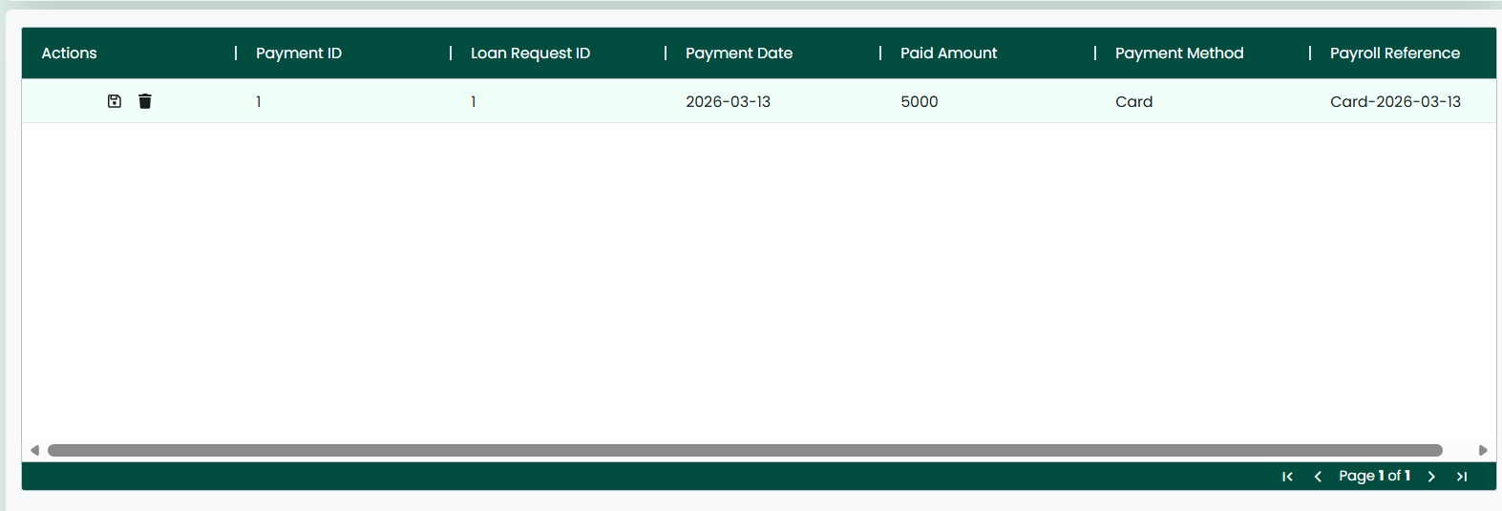
Additional Features
✧ The Reload button can be used to refresh the page, clearing all fields and resetting the screen to its initial state.
✧ The Excel option is available to download the displayed data for reporting purposes.

C H A P T E R

6 Loan Repayment
Schedule
✧ Clicking on the Loan Repayment Schedule tab navigates the user to the Loan Repayment Schedule screen.
✧ The screen is used to define and manage the repayment schedule for employee loans.
✧ Each of the Payroll screens includes input fields such as Schedule ID, Loan Request ID, Installment Number, Installment Date, Principal Amount, Interest Amount, Total Installment, and Payment Status. These fields help in tracking installment-wise loan repayment details.
✧ This screen also features ‘Save’ and ‘Reload’ buttons located at the top-right corner.
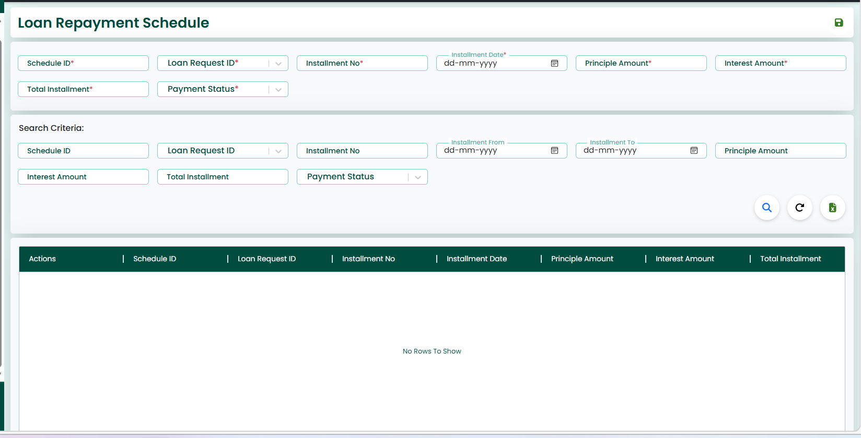
Data Entry Section
✧ On this screen, the user must enter the required details such as:
- Schedule ID
- Loan Request ID
- Installment No
- Installment Date
- Principal Amount
- Interest Amount
- Total Installment
- Payment Status
✧ After entering the data, by clicking the ‘Save’ button, the repayment schedule details will be saved successfully.
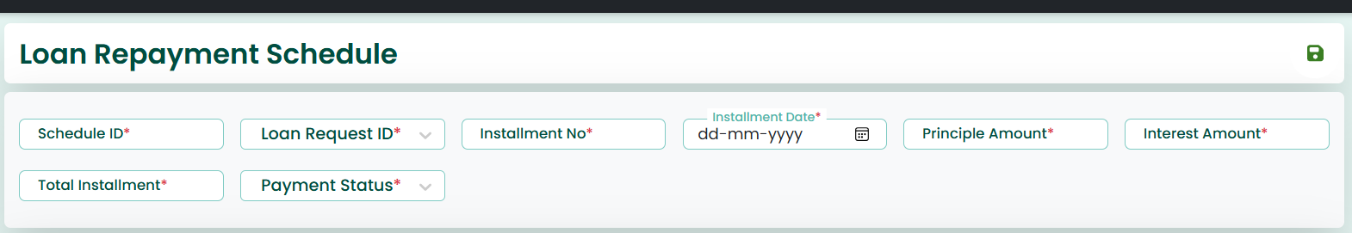
Search Criteria Section
✧ The Search Criteria section allows the user to search for existing repayment schedule records. The user can enter or select fields such as:
- Schedule ID
- Loan Request ID
- Installment No
- Installment From
- Installment To
- Principal Amount
- Interest Amount
- Total Installment
- Payment Status
✧ Clicking on the Search button/icon will display the saved data for this screen. The user can view the records in the grid below.
✧ The user can select the required record and perform necessary actions.
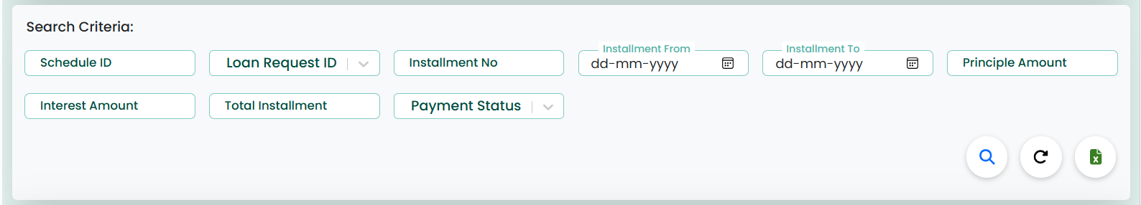
Actions (Edit/Delete)
✧ If the user wants to update or delete the data, Edit and Delete options are available in the Actions column. These allow the user to modify or delete the data as needed.
Update & Delete Functionality
✧ Once the data is fetched, if the user wants to update it, they can modify the fields and save the changes.
✧ If the user wants to delete the record, they can click the delete option to remove the data.
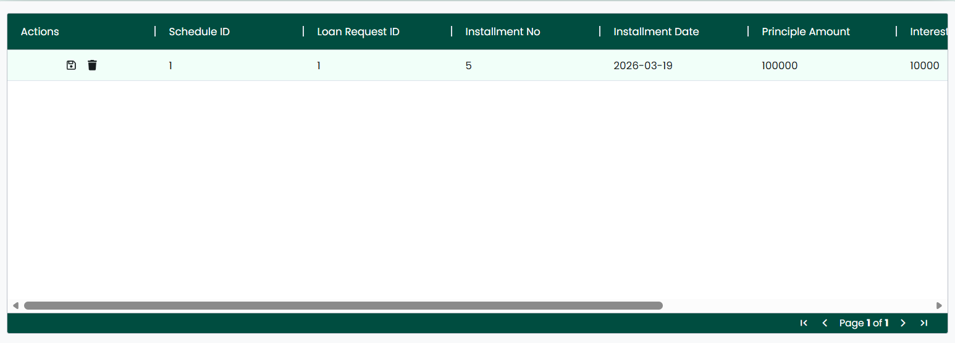
Additional Features
✧ The Reload button can be used to refresh the page, clearing all fields and resetting the screen to its initial state.
✧ The Excel option is available to download the displayed data for reporting purposes.

C H A P T E R

6 Loan Status
History
✧ Clicking on the Loan Status History tab navigates the user to the Loan Status History screen.
✧ The screen is used to track and maintain the history of status changes for employee loan requests.
✧ Each of the Payroll screens includes input fields such as History ID, Loan Request ID, Old Status, New Status, and Remarks. These fields help in monitoring the lifecycle and status transitions of loan requests.
✧ This screen also features ‘Save’ and ‘Reload’ buttons located at the top-right corner.
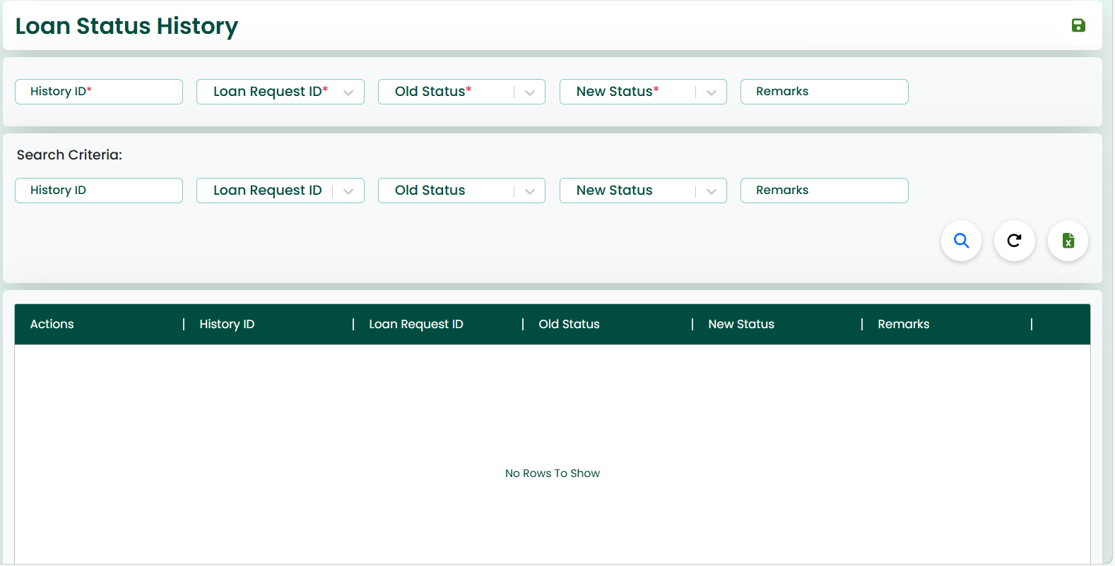
Data Entry Section
✧ On this screen, the user must enter the required details such as:
- History ID
- Loan Request ID
- Old Status
- New Status
- Remarks
✧ After entering the data, by clicking the ‘Save’ button, the status history details will be saved successfully.
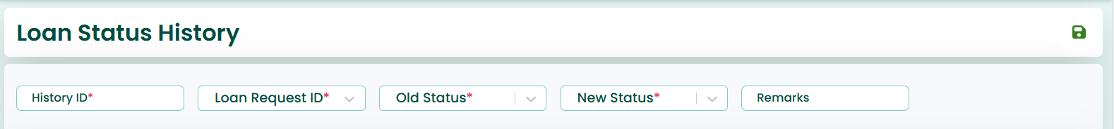
Search Criteria Section
✧ The Search Criteria section allows the user to search for existing status history records. The user can enter or select fields such as:
- History ID
- Loan Request ID
- Old Status
- New Status
- Remarks
✧ Clicking on the Search button/icon will display the saved data for this screen. The user can view the records in the grid below.
✧ The user can select the required record and perform necessary actions.
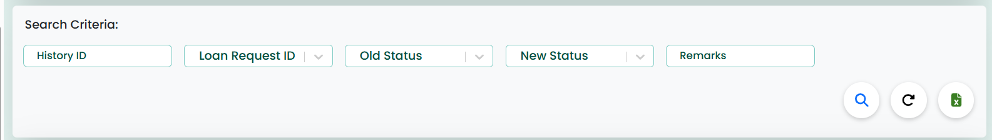
Actions (Edit/Delete)
✧ If the user wants to update or delete the data, Edit and Delete options are available in the Actions column. These allow the user to modify or delete the data as needed.
Update & Delete Functionality
✧ Once the data is fetched, if the user wants to update it, they can modify the fields and save the changes.
✧ If the user wants to delete the record, they can click the delete option to remove the data.
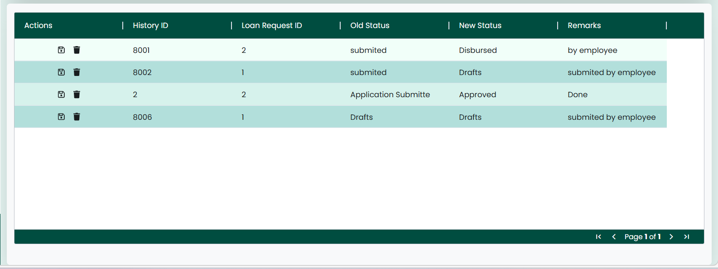
Additional Features
✧ The Reload button can be used to refresh the page, clearing all fields and resetting the screen to its initial state.
✧ The Excel option is available to download the displayed data for reporting purposes.

